Summary Curriculum Vitae (02)
Professor Dr. Yousef Mustapha Abu Day’yah, President
National Research Center
P.O. Box: 5340
Palestinian Authority, Gaza Strip
Email:yabodaya@yahoo.com
Tel/Fax: +970 8 282 4157
Mobile: +970 599 493760

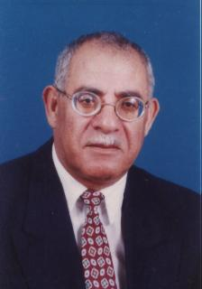
- Professor Dr. Yousef M. Abu Day’yah is the president of the National Research Center in Palestine. He is basically dealing with several issues for R & D in Gaza strip and West Bank and trying to improve the Palestinian Education system and Research Management Process. He is also developed partnerships with the Egyptian National Research Center in Cairo, Ein Shams University and Halwan University.

- He was the founder and the President of AL-Aqsa University in Gaza Strip for many years and started as acting the dean of the Faculty of Education in Gaza- Public Governmental domain until he promoted to be adviser of the president of Education and Higher Education Council of the Ministry of Education and Higher Education.

- He is working on Biochemical studies on effect of some phenolic compound of olive cake on Wheat Coleoptiles Elongation in Palestine with several papers including wheat germination, Isolation of the olive by product... etc.

- As well as lectures, consultation and process control, management science, system science and Biochemical engineering at several Palestinian Universities in Gaza.

- Prof. Abu Day’yah is frequently participates in a national and International conferences. He has presented and published numerous papers and articles in Arabic and English.

